Human Vital Sign Monitoring and Security Applications Using Correlated MEMS Accelerometer and Indium Oxide Nanowire Gas Sensors

Technical Report #2

Submitted by
William Branham
University of Southern California
3620 South Vermont Avenue, KAP 132
Los Angeles, California 90089-2533
Tel. (503) 467 9845
Email wbranham@usc.edu

Date: March 25, 2009

Work performed at USC

This page intentionally left blank

Abstract

The purpose of this report is to explain the methods, software, hardware, and signal processing that are necessary to detect and analyze periodic motion in a noisy environment using an accelerometer and correlating that data with an Indium Oxide nanowire field effect transistor gas sensor in order to monitor human vital signs. Specifically, a MEMS accelerometer (a three axis low-g micromachined accelerometer manufactured by Freescale Semiconuctor) placed on a USB interfaced dongle was used to monitor the movement caused by respiration by an individual and to detect sudden increases in acceleration (such as from falling). For measuring the acceleration caused by respiration, the dongle was placed on the stomach of the subject and the accelerometer recorded the acceleration caused by the rise and fall of the diaphragm. The gas sensor was placed directly beneath the subject’s nose as they breathed. Possible applications for this sensor include vital sign detection in emergency medical situations and monitoring infants or people who are disabled or elderly. Additionally, the accelerometer was used to sense a human walking across a hollow floor. This was done by recording the acceleration of the dongle caused by the vibrations sent through a structure by the feet of the human. One application of this sensor is its use in a comprehensive security system.

All data was collected from the dongle via a USB connection to a computer, where it was displayed in real-time, logged, and analyzed by a program written in MATLAB. The data from the two sensors is in principle meant to be correlated with each other in order to reduce error through redundancy. Additionally, since the data was very noisy, both signals were processed using a combination of a moving average and a fast Fourier Transform. In the first case, processing the raw data showed that it was possible to find the respiration rate of a subject and to sense if that subject had ceased breathing or had fallen. In the second set of experiments, it was shown that it was possible to detect a human moving across a surface by the vibration through the floor.

Table of Contents

Abstract 3

1. Introduction 5

2. Hardware architecture 6

3. Software 6

4. Performance measurements 7
4.1 Introduction 7

4.2 Measurement Section 1 - Respiration 7
4.3 Respiration Data Discussion 8
4.4 Measurement Section 2 – Intruder Detection 10
4.5 Intruder Data Discussion 11

5. Conclusions 12

6. Distribution list 13

1. Introduction
The purpose of this report is to explain the methods, software, hardware, and signal processing that are necessary to detect and analyze periodic events in a noisy environment using an accelerometer and gas sensor. The measurement of periodic movement is critical to analyze many natural and anthropomorphic systems that make up everyday life. The focus of this report is mechanical biorhythms, particularly the detection of the gait and respiration rate of an individual human.

As in all real systems, noise is prevalent in measurements of biorhythms. Without proper signal processing, it is nearly impossible to analyze data or isolate the rhythm being studied. In the case of the accelerometer, noise can come from the detection of acceleration from other biorhythms (such as the heart pumping blood) or inadvertent movement by the subject. For the gas sensor, noise could come from changes in ambient temperature, inadvertent motion of the dongle, wind or other random atmospheric changes. To make use of data in this kind of environment, a function was needed that recognized that a periodic signal was being recorded and that could alert a human monitor if conditions changed. Such a sensor could be used in tandem with motion sensors, cameras, and alarms in either a comprehensive security system or in-home medical monitoring system. We imagine a home equipped with sensors that could constantly monitor the location and condition of a patient with severe physical or mental disabilities/risks. This system could be connected to emergency services in the event a patient suffers an injury.

2. Hardware architecture

Figure 1 shows the schematic of the MEMS accelerometer used for this report. The instrument was manufactured by Freescale Semiconductor (model MMA7361L). The device is 3mm by 5mm by 1mm and requires only 400μA of current to run (or 3μA in sleep mode). Although the accelerometer features two sensitivity modes, only the more sensitive setting was used (+/-1.5g instead of +/- 6g). The device also features a built in low pass filter, however this is an inadequate amount of signal processing to extract meaningful data. It can be exposed to 5000g acceleration, dropped from 1.8 meters onto concrete, and cooled/heated to -25ºC and 145ºC respectively without malfunction. The device was attached to a USB device and microcontroller that served as an interface to a computer and MATLAB.

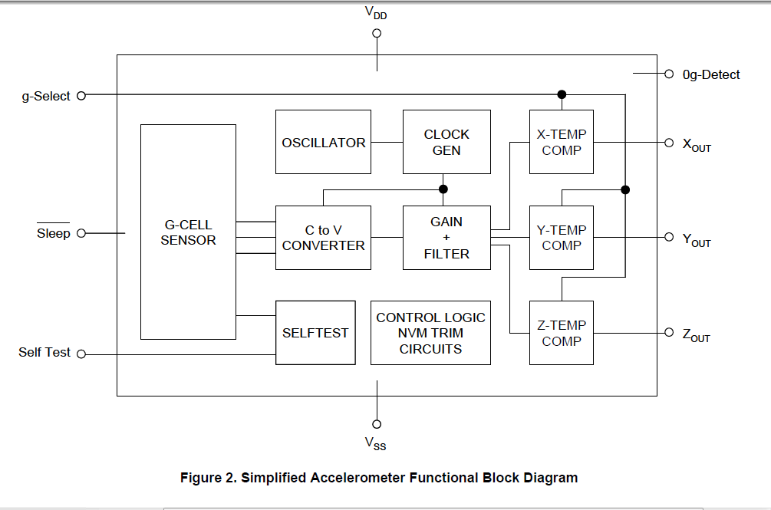
Figure 1: (a) Diagram of the MMa7361L accelerometer with 14 leads and (b) a functional block diagram.

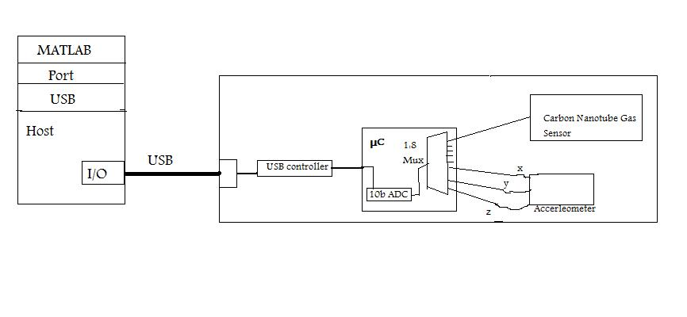
Figure 2: Functional block diagram of sensor platform and data logging/analysis of hardware and software architecture.
Figure 3 shows an example of an indium oxide nanowire bridging the gap between two golden diodes. The gas sensor used in the experiments had a similar structure, but far more nanowires connected two strips of saw-toothed golden diode. A nanowire is a nanostructure, with the diameter of the order of a nanometer (10−9 meters). The conductance of electrons across the nanowires that bridge the gold diodes changes as NO2, CO, ethanol, water, and other molecules in the air land on or are knocked off of the wires. The sensor is sent an analog voltage level by MATLAB, and returns another voltage level which is converted back into digital data by the onboard ADC. The MATLAB program then computes the change in resistance across all of the bridges using the voltage value returned and the current that was sent across the bridges.

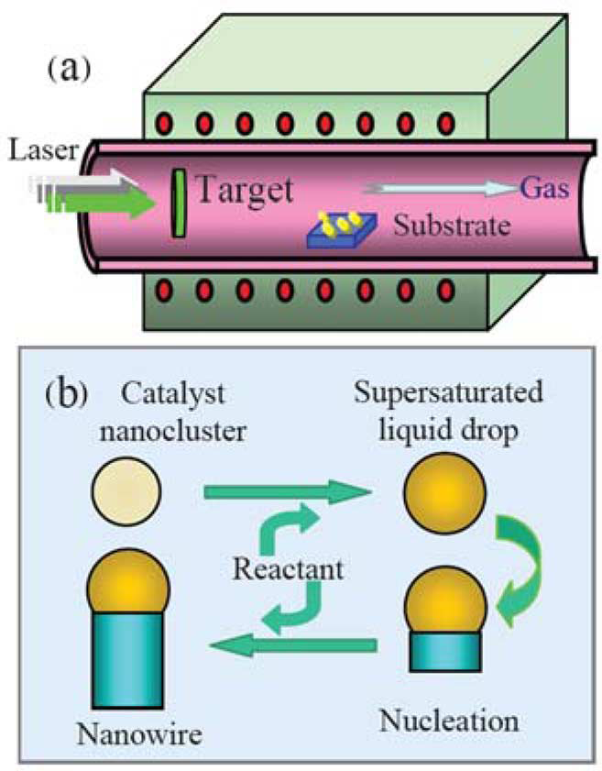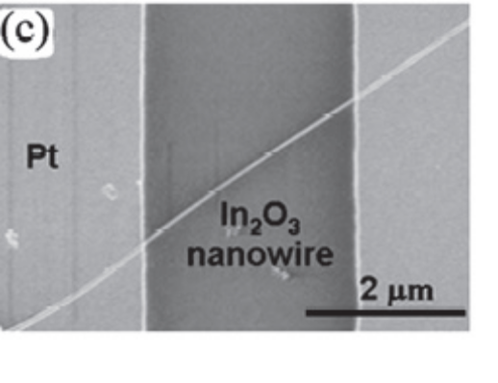
  - Figure 3: (a) Laser ablates Indium solid into vapor in chamber (b) where nanowire growth is catalyzed by gold microparticles. The Indium vapor combines with oxygen in the chamber to form indium oxide. (c) Indium oxide nanowire bridging two golden diodes. The wire is at least 6 μm long and has a diameter of 10 nm.

3. Software
Programs written in MATLAB were used to draw data from the device, log the data in a text file, and process/display the data recorded in real-time. The processing/display program contained all of the digital signal processing functionality, including a simple low pass filter (moving average) and a fast Fourier Transform. The transform utilized a smoothed square filter (top hat) centered on the frequency with the maximum power detected from the signal. In the case of the real-time data, the filter window was created such that only the expected frequency was shown in the filtered data window. For the accelerometer detecting respiration, this top hat was centered around the expected rate of .15 Hz (or about 10 breaths per minute). In the case of the detection of vibration from human locomotion, a custom smoothed box filter range was used to better isolate the desired frequency of movement. The program then performed an inverse Fourier Transform on the resultant array of values, producing the smoothed/filtered data in relation to time (rather than frequency versus amplitude).

4. Performance measurements

4.1 Introduction
The following is the data that was collected during experiments on the accelerometer. The first two sets of data are a part of the vital sign (respiration) application for the accelerometer and gas sensor. The first set of data is for respiration while the subject was lying flat on their back and moving minimally. The second set shows the same periodic biorhythm using the gas sensor and different signal processing.
The graphs show the original signal, power spectrum of the signal, the filter used on the signal, and the resulting filtered data. These graphs are representative of a larger set of data collected for both respiration and walking. The data for intruder detection was collected in an improvised system, with a wooden table acting as a hollow floor. The dongle was secured directly to the underside of the table so that the positive Z axis pointed to the floor and the subject walked with a steady pace on top of the table. Several control data sets were taken with the dongle at rest.

4.2 Measurement section one - Respiration
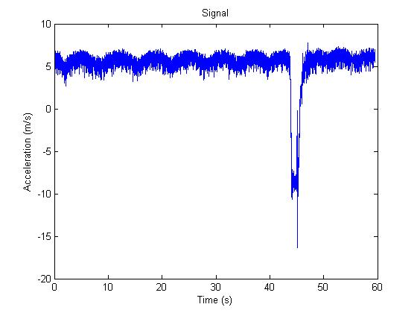
(a)

Figure 4: Original signal taken from the accelerometer; although it already it seems to indicate periodic behavior, it is overshadowed by noise. Note that the large spike in acceleration around 45s is due to the sensor falling off the subject.
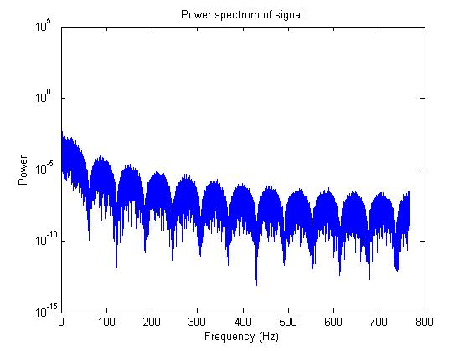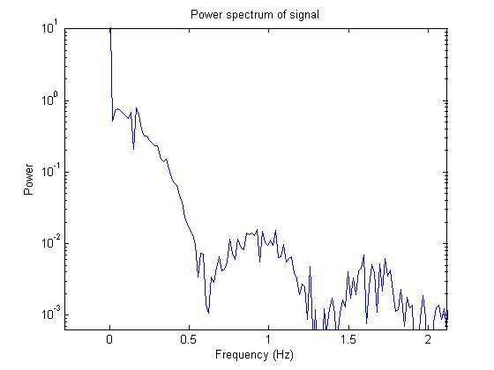
(a) (b)
Figure 5: (a) Power spectrum of signal; shows clear power peak at between 0 and 100 Hz, however the resolution is too low to determine the real frequency, which should be around .1 to .5 Hz (based on average human respiration rates). (b) This power spectrum graph clearly shows a power spike around the expected frequency. (d) The filter used for the Fourier transform was smoothed and centered at approximately .5 Hz.
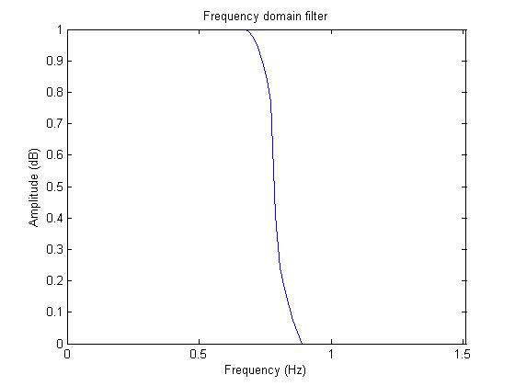
(c)
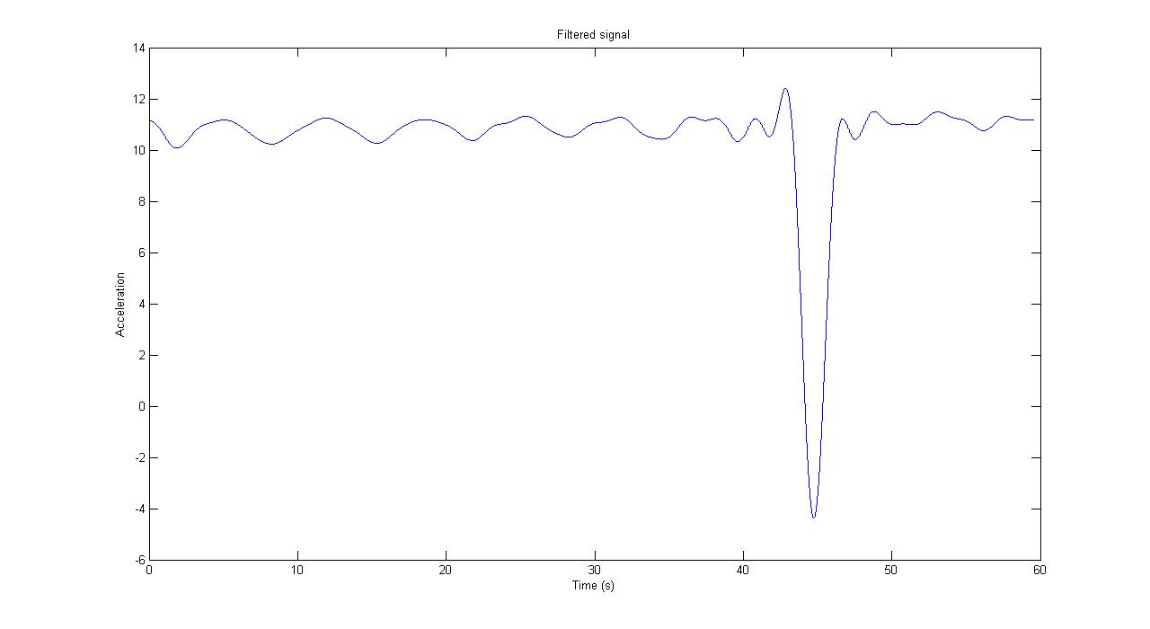

Figure 6: The data after a low-pass filter (moving average) and a fast Fourier Transform have been performed. The rhythmic cycle of breathing is clearly discernable (again, note that the sharp spike in acceleration was due to the device falling off the subject).
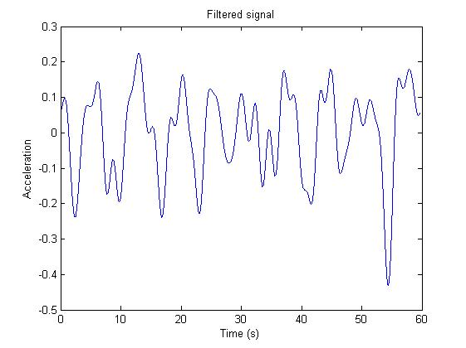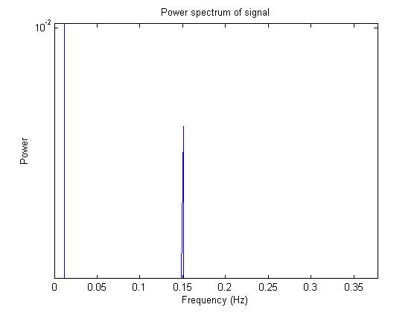
Figure 7: (a) Data taken in more realistic setting with the subject walking around and moving normally – each major spike of .4 magnitude represents a breath taken and each smaller spike of .1 represents either a step taken or other movement by the subject. (b) shows a clear power spike at the expected frequency of .15 Hz

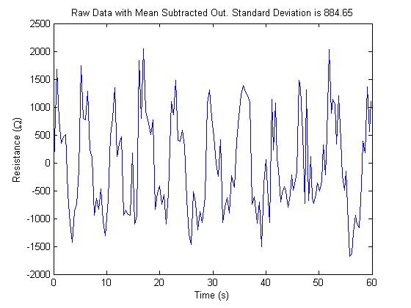

(a)
Figure 7: Data from nanowire gas sensor showing clear spikes in resistance across the nanowire bridges as subject breathes steadily on to the device. (a) shows the raw data minus the mean calculated by MATLAB. (b) is the original data over time and (c) is the temperature readings over time.

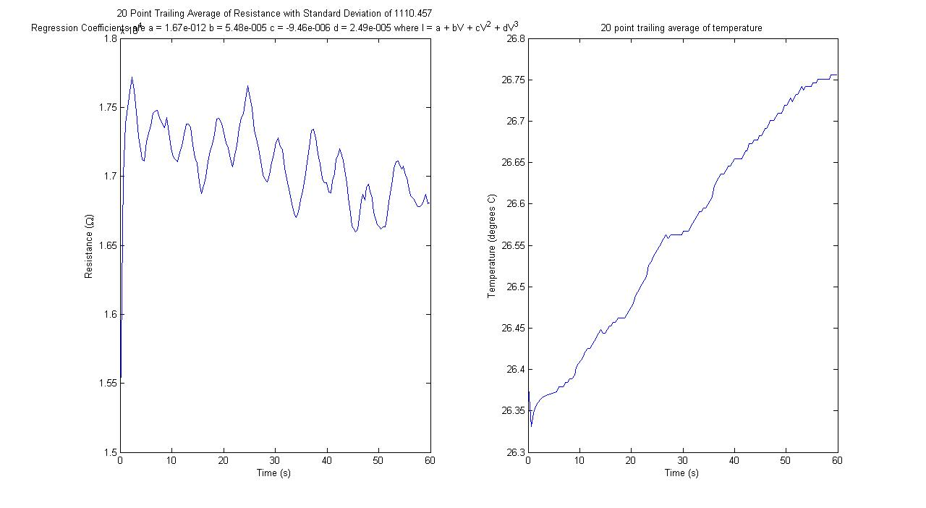
(b) (c)

4.3 Respiration Data Discussion
The data clearly show the feasibility of measuring the respiratory rate of a subject for the purposes of medical evaluation. Each peak represents a breath taken by the subject as their diaphragm rises and air is inhaled, which causes the dongle to accelerate with it and the gas sensor to change resistivity across the nanowire bridges. The data for the accelerometer is also at the correct magnitude, since acceleration due to gravity is approximately 10 m/s^2 and the data is near that value (taking in to account the acceleration from the diaphragm). Although the spike in acceleration from the device falling may indicate a weakness in the accelerometer’s ability to cope with real-world noise and accidents, such spikes could likely be accounted for and filtered out with other methods or taken into account by technician analysis. Alternatively, the sensor could be used to both measure respiration and to detect if a patient has fallen and hurt themselves. It should also be noted that the plotting program automatically found the frequency in the signal with the maximum power, requiring little calibration by users. This is beneficial in regards to the medical environment the device would be operating in, since users would be preoccupied with other, more critical medical instruments (or if this sensor were used in the home, a medical center would only be alerted if respiration fell below a critical level). Since both methods seem to be accurate at sensing whether respiration is occurring, it would be beneficial to correlate the streaming data from both sensors in order to reduce false alarms and provide a fail safe if one of the devices should stop working.
Additional work is also required to account for different respiration rates of patients performing different activities such as exercise or sleep.
4.4 Measurement section two – Walking

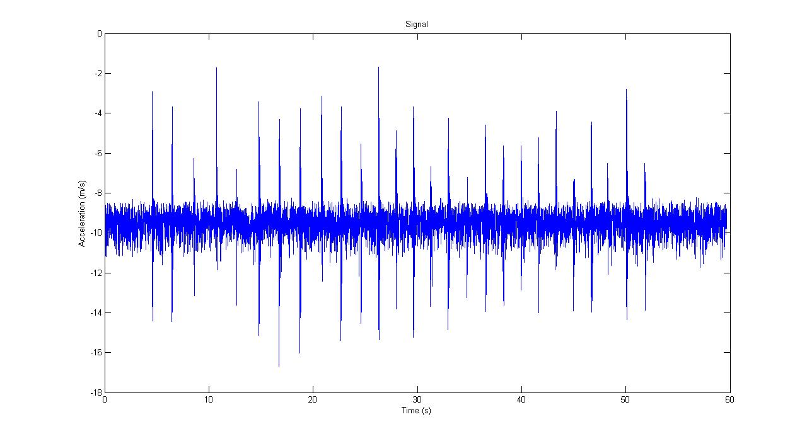
Figure 8: Unfiltered data showing clear spikes in acceleration. However, the spikes are surrounded by noise that could hinder analysis of the data in order to detect a human intruder.

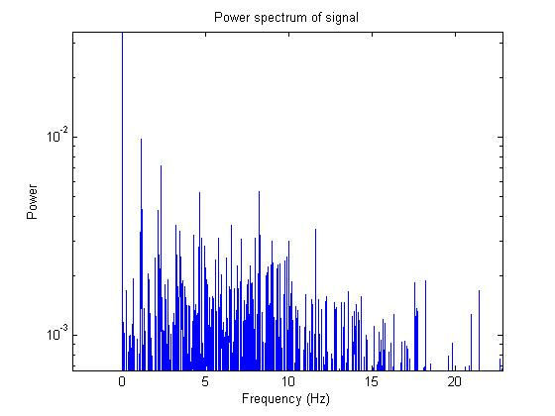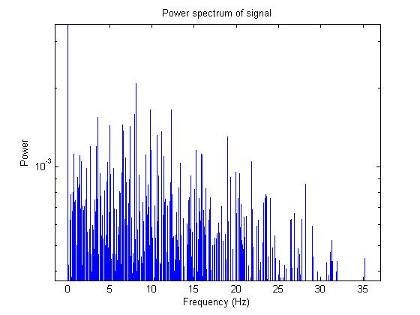
- (b)

Figure 9: Power spectrums used to establish threshold of alarm with (a) experimental data (showing a maximum peak of 10^-2) and (b) control data sets (showing a maximum peak of a little over 10^-3, one degree of magnitude smaller than the data with periodic motion).
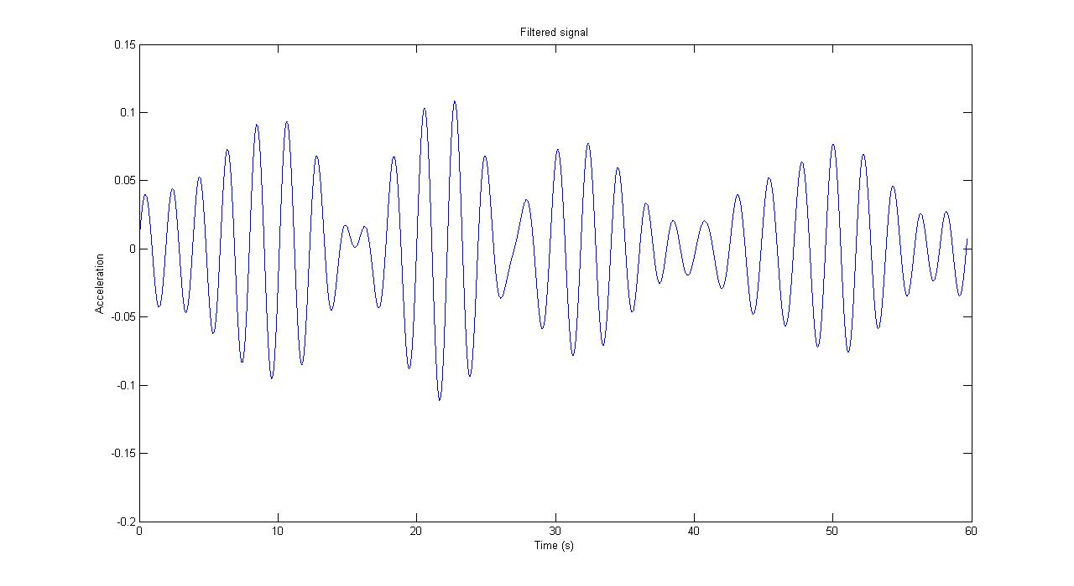
Figure 10: Filtered signal of intruder walking with a gait frequency of approximately .5 Hz (or one step every two seconds); Each peak represents a single foot-step taken by the subject.

4.5 Walking Discussion

The data shown here clearly represents the ability of the sensor to detect human motion through vibration. Each peak on the filtered signal represents a step taking by the subject. The peak signal power was also used to determine if any periodic movement was being detected by the sensor, as discussed above. Since the purpose of the sensor was to detect a human intruder, the software should send an alert (audio, in this case) to the user. Using several sets of control data (represented in figure 5b), it was determined that data which did not show a frequency with a power greater than 10^-2.5 did not indicate periodic movement was occurring around the sensor. Thus, a simple “if” function that searched the power spectrum array to find the maximum power value at a certain frequency and compared it to the threshold value of 10^-2.5 was coded. If the data set contained a value above the threshold, the alarm sounded. The data represented in the first four figures in this section show a slower gait than what might be expected in the real world. Most of the data collected showed a foot-step frequency of close to 1 Hz or more, however, those data were less illustrative of ability of the sensor to clearly show human movement. Thus this data set did not trigger the alarm because its maximum power did not pass the threshold.
5. Conclusions

The data collected for this report support the conclusion that MEMS accelerometers can be used to monitor human vital signs and to detect intruders by vibration. In a relatively controlled environment, the sensor was successful in detecting the periodic movement of interest despite white noise. Additionally, the data collected from the gas sensor support the conclusion that nanowire-based gas sensors are sensitive and agile enough to accurately record the respiration rate of a human.

Although this report did not signal process or plot the data in real-time, it is certainly feasible to do such computation in MATLAB. Real-time processing would be critical in both applications discussed in this report since both monitor dynamic/emergency situations which demand immediate response by the user. Another limitation of the device that would hinder its real-world application is that the sensor must be connected to a computer via USB cable for both power and data transmission. Adding a mobile power supply and wireless data transmission functionality would enhance the usability and practicality of this sensor technology. Further calibration of the intruder detection system is also necessary to determine a more accurate threshold would improve the reliability of the system and cut down on both false alarms and missed intruders. As noted in the discussion above, slower gaits can pass below the current experimental threshold. Since intruders may learn to walk with non-periodic gaits, integration of this sensor into contemporary alarm/security systems is critical since the data from multiple sensors could be correlated to ensure an intruder does not bypass the sensors with out tripping the alarm. Another area for further research might be the use of multiple accelerometers that could triangulate the position of a person based on the different accelerations each sensor detects.

In the area of medical sensing, the same limitations of mobility currently inhibit the application of this sensor in the real-world. A wireless device that continually dumps data into a central location that reports to a medical monitoring center is necessary. Further development of the ergonomics of both the device and how the signal is interpreted by a computer is essential. For instance, the MATLAB code does not currently recognize that different respiration rates are normal in everyday life (from walking up stairs, exercising, or going to sleep). One idea is to have a switch on the device that tells monitors what level of activity to expect from the patient (i.e. exercise mode, sleep mode, etc.). Since that solution is of course crude and cumbersome on the patient, a more sophisticated program that learns to recognize a patient’s daily routine of activity may resolve this issue. Despite these limitations, this report has shown that such a sensor is a feasible, accurate, and convenient way of monitoring a patient’s condition remotely.
6. Distribution list

Report number – Report title (1 copy total)

A.F.J. Levi 1 copy
Professor of Electrical Engineering
University of Southern California
3620 South Vermont Avenue, KAP 132
Los Angeles, California 90089-2533

Tel. (213) 740-7318
Fax. (213) 740-9280 fax
Email. alevi@usc.edu
Web. http://www.usc.edu/alevi

